# Team Information

|  |  |
| --- | --- |
| **Team # on Canvas**: | 5 |
| **Team members**: | Shen, Jerry -- 91605061 Feng, Derek -- 55402550 |

# Project Title

|  |
| --- |
| The Life Alerting Safety Cane |

# Updated Project Description and Approach

*(Describe the solution you are implementing including architecture schematic and communication protocol (Wi-Fi, BLE, ...). Max 500 words).*

|  |
| --- |
| We implemented a safety cane targeted to be used by patients or elderly people. It features an accelerometer for fall detection, as well as an LED light to indicate if a fall has been detected. If the cane detects a fall, the LED lights up and microcontroller inside the cane that sends an alert through Twilio’s SMS service API to the appropriate emergency contact. There is also a GPS sensor attached to the cane which is pushing live GPS data to the ThingSpeak, which is a cloud service for IoT data collection and analysis.  Following Architecture 2 (sensor-cloud), the cane is connected to the user’s phone via WiFi  hotspot and uses it to send the SMS alert with the GPS location. However, to prevent false positives,  such as a cane falling on its own, there is a button the user can press to send out another alert saying that it was a false alarm. |

# 

# Updated (final) Hardware list of Project Components

*(The list and quantity of all the components you have used for your project)*

|  |  |
| --- | --- |
| **Component/part** | **Quantity** |
| Arduino Uno | 1 |
| Button [from Seeedstudio Grove kit] | 1 |
| GPS (Adafruit Ultimate GPS Breakout - 66 channel w/10 Hz updates -  Version 3) | 1 |
| Accelerometer | 1 |
| External Battery | 1 |
| LED light | 1 |
| Raspberry Pi | 1 |
| Walking Cane | 1 |
| Breadboard | 1 |
| Necessary cables/connectors | x |

# Project Tasks completed

*(Describe the tasks that have been already completed. Max 400 words).*

|  |
| --- |
| We completed all the tasks in our Updated Project Description and Approach. To summarize:   * Acquired a cane * Built the “smart” portion of the cane using the sensors & Arduino/Raspberry Pi * Connected our hardware with our mobile hotspot, ThingSpeak & Twilio services * Built an enclosure for the sensors and Arduino/Pi & attached to the cane * Filmed demos for both use cases due to demo constraints (mentioned below) |

# Challenges/roadblocks

*(Describe the challenges that you have faced so far and how you solved them. Max 300 words).*

|  |
| --- |
| * We initially intended to 3D print a whole cane and an enclosure for the Arduino, Pi, and sensors, but due to time and feasibility constraints we bought a cane and made enclosure out of cardboard. * We also faced ESP8266 troubles; despite managing to setup it as webserver, we were unsure of how to go on from there so we used a Raspberry Pi to connect to the Arduino. * Another challenge was that the GPS requires direct line of sight to the sky in order to have readings, so we recorded the demo outside. Also, we initially planned to have the GPS unit enclosed, but we worked around the issue by making an additional exposed layer outside of the enclosure. |

# Project Results

*(Write a brief description of results, including charts, pictures and links to videos as needed to demonstrate how the developed IoT platform solves the targeted problem. Max 500 words).*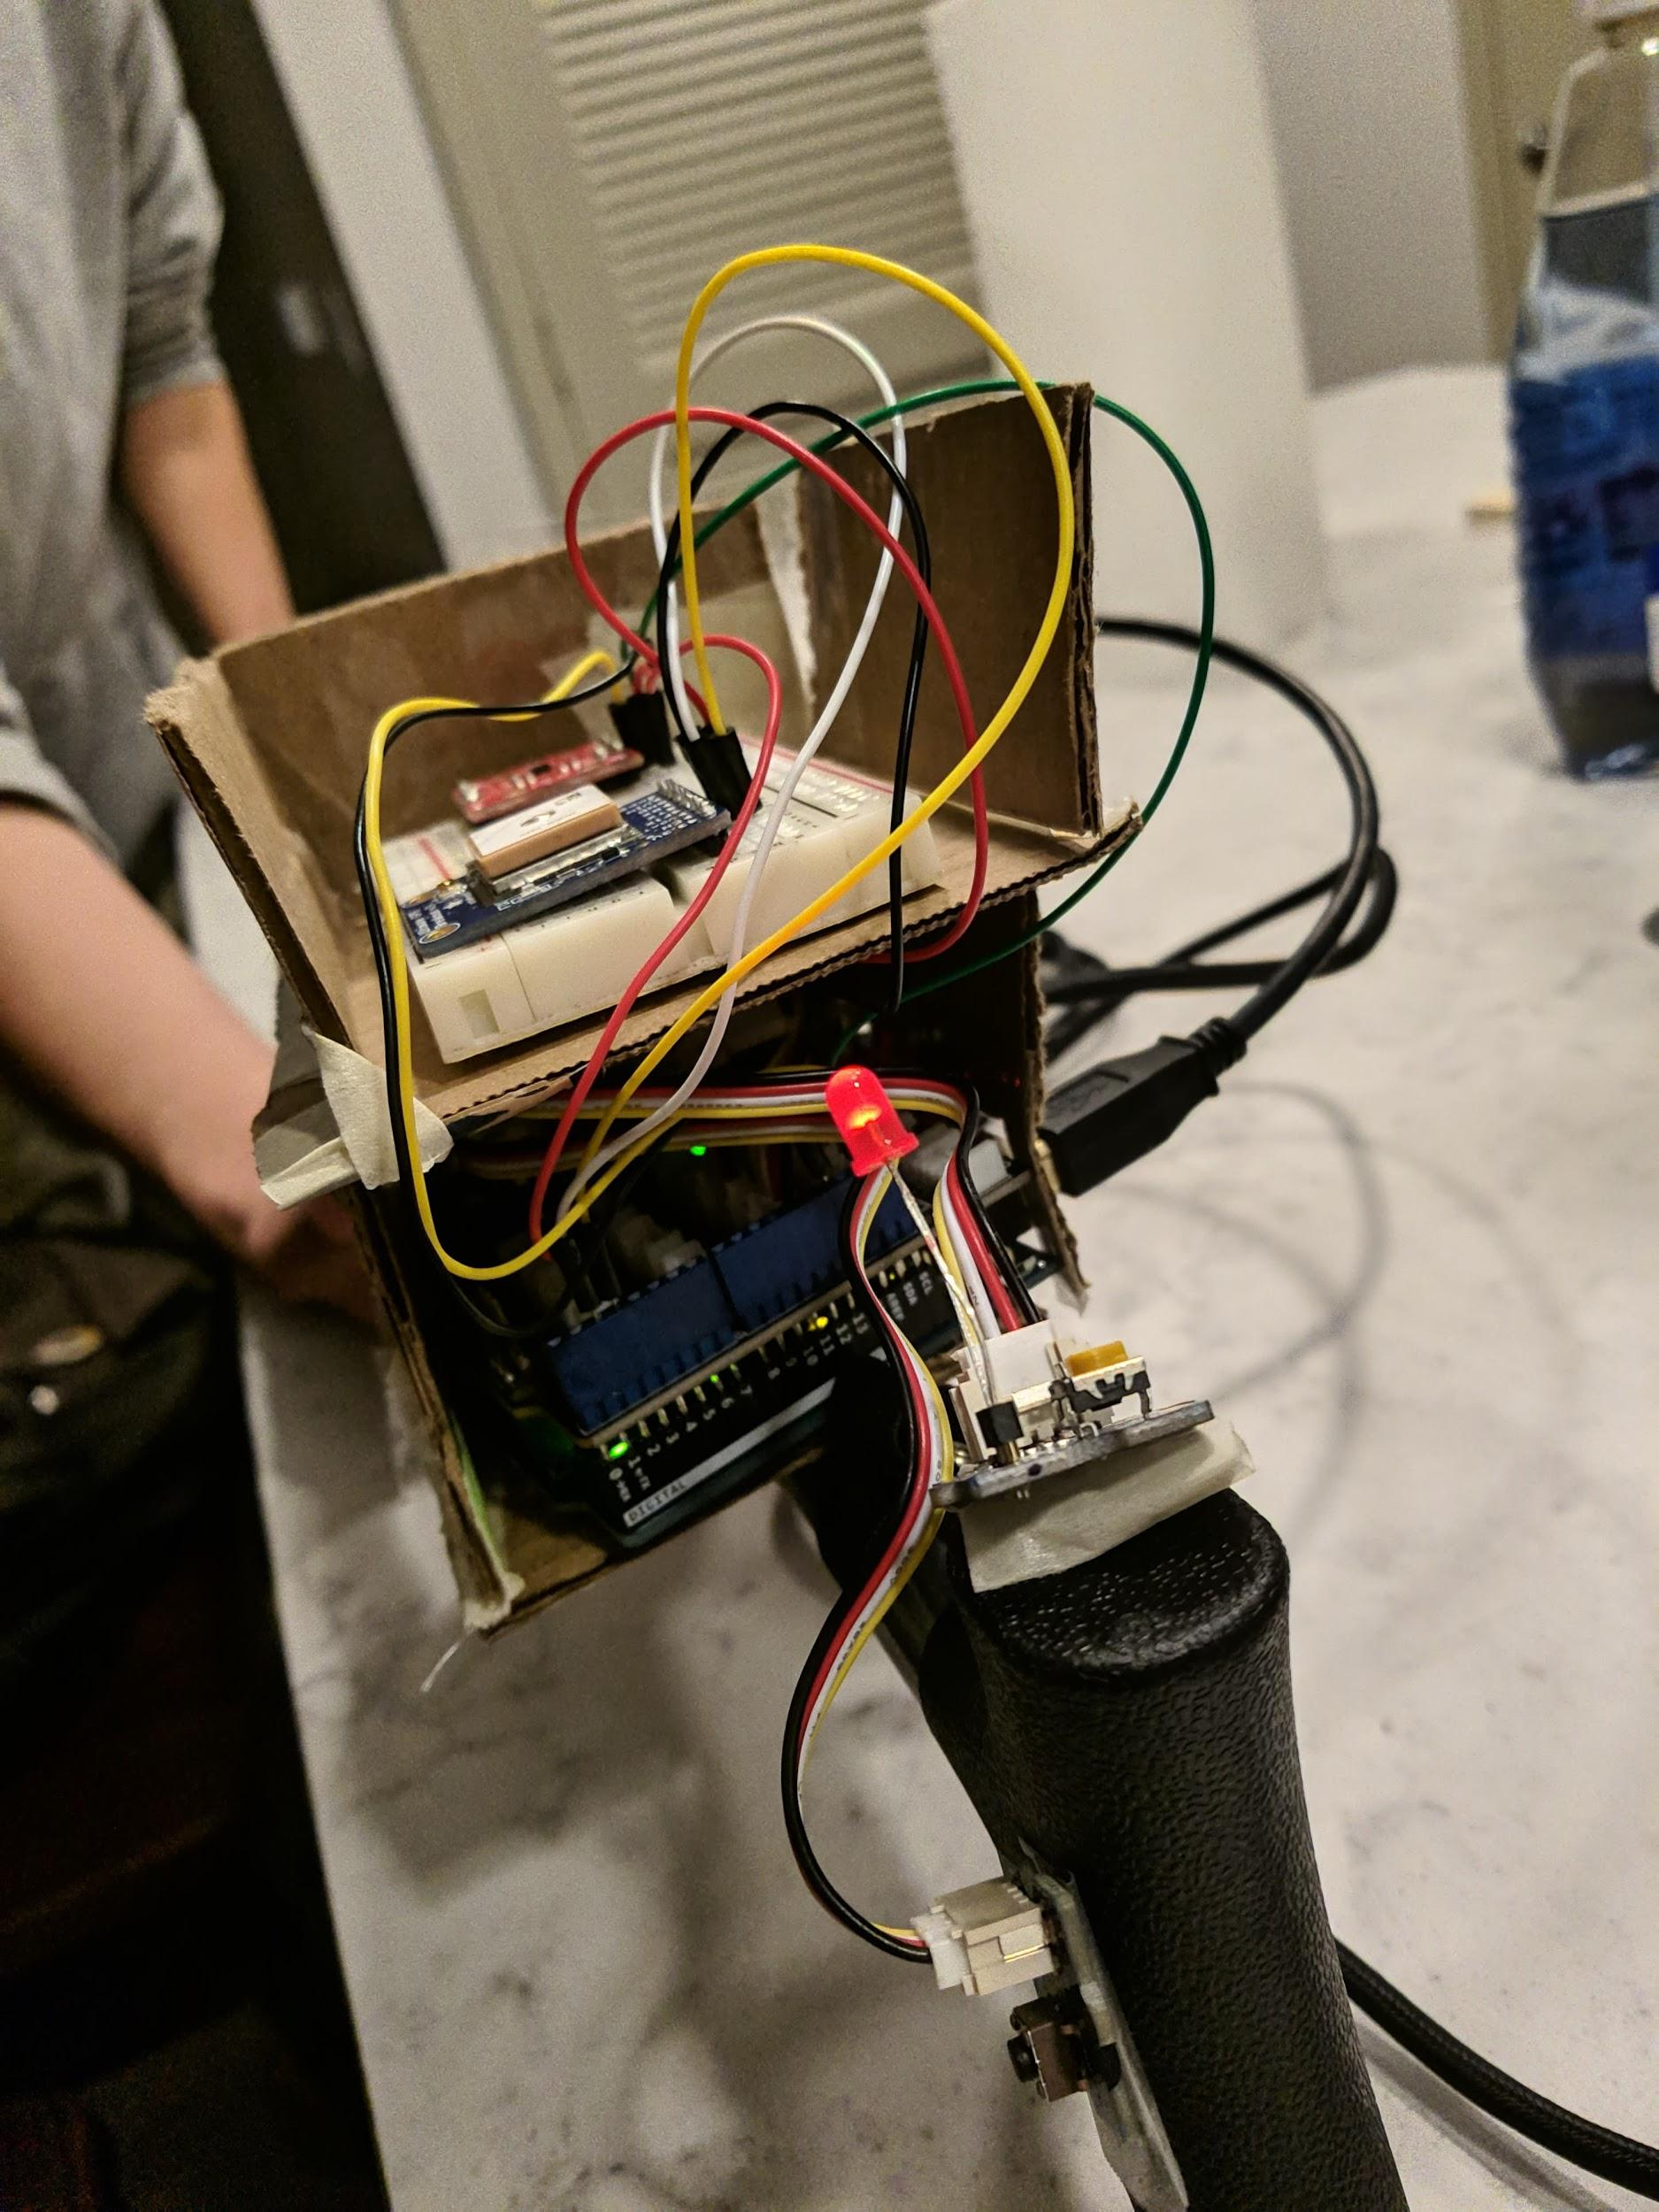

|  |
| --- |
| The picture on the left shows the accelerometer and the GPS located at the top (had to be exposed to the sky hence no cardboard covering it).  The picture to the right is of the Arduino Uno and the Raspberry Pi units located underneath.  Fall Detected: <https://www.youtube.com/watch?v=8a6CDG7puFw>  False Alarm: <https://www.youtube.com/watch?v=_4bYu8FW2i8>   * These two links are demos of how our cane works; the first shows the demo of the “fall detected” case, where the user doesn’t press the false alarm button and an SMS alert is sent with GPS coordinates that pulls the most recent reading from ThingSpeak and sends the location in the form of a google maps link that can be clicked to visualize the location. * The “false alarm” case shows the user pressing the button to signify that they are OK and the cane just fell (and not them) by mistake, in which the appropriate false alarm SMS message is sent accordingly.   ThingSpeak cloud data: <https://thingspeak.com/channels/926596>    (as a reminder from our presentation: there isn’t much variation in these readings because we worked mostly in the same, static locations in Irvine to test the sensor and demo our cane) |

# Weak points / Future work

*(Mention at least two points of your project that have room for improvement. These points can be additions to the existing project setup (components) or improvement of the current implementation. Max 300 words).*

|  |
| --- |
| * We could greatly improve our cane by investing in a GPS that does not need a clear line of sight to the sky, which is important because it would be essential for detecting falls within homes and buildings. * As this is just a prototype, there is room for improvement in the structure/layout of the cane. It is a bit bulky in the current state and there is a lot of exposed sensors, wires, etc. Additionally, from an aesthetic standpoint, it is not the most visually appealing since we used cardboard and tape for the enclosure. |